Chapter 4

**Analysis and Results**

* 1. **Results for Stress-Strain Curve**

The model that was trained on the stress-strain curve data was used to predict values (stresses) on unknown composite materials for every volume fraction. This, in turn, was used to construct the corresponding stress-strain curve.

A comparison has been made between the *actual* and *predicted* stress-strain curves for a particular material at different volume fractions. The resulting graphs are as follows:

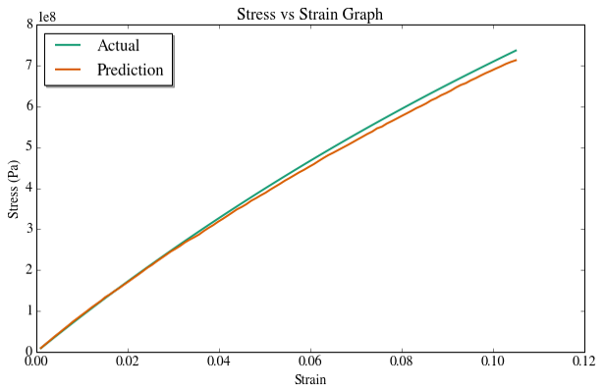

**Figure 4.7**: Actual and Predicted Stress-Strain Curves at 5% Volume Fraction

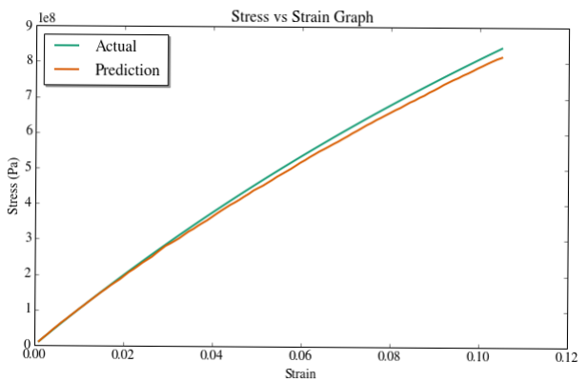

**Figure 4.7**: Actual and Predicted Stress-Strain Curves at 10% Volume Fraction

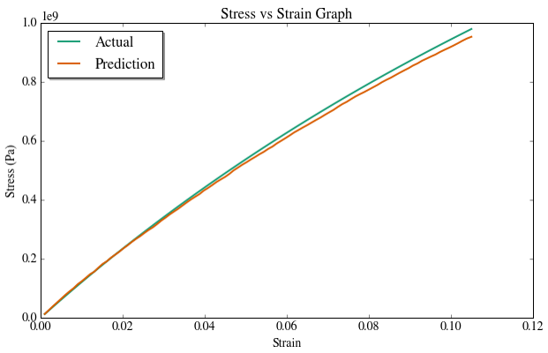

**Figure 4.7**: Actual and Predicted Stress-Strain Curves at 15% Volume Fraction

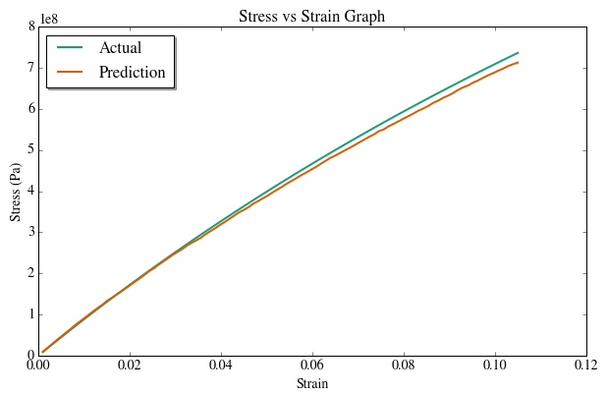

**Figure 4.10**: Actual and Predicted Stress-Strain Curves at 20% Volume Fraction

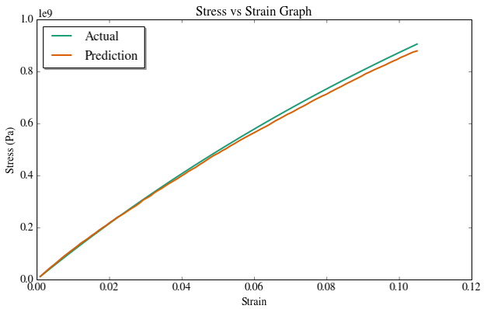

**Figure 4.7**: Actual and Predicted Stress-Strain Curves at 25% Volume Fraction

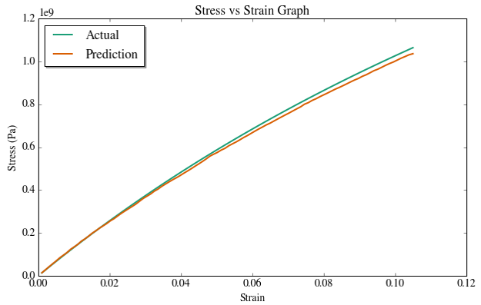

**Figure 4.7**: Actual and Predicted Stress-Strain Curves at 30% Volume Fraction

Quantitatively, the *coefficient of determination* values are as follows:

|  |  |
| --- | --- |
| **Volume Fraction (%)** | **Coefficient of Determination (R2)** |
| 5 | 0.95 |
| 10 | 0.96 |
| 15 | 0.95 |
| 20 | 0.99 |
| 25 | 0.97 |
| 30 | 0.96 |

From the above graphs and corresponding R2 values, it is clear that the ML model works extremely well on unseen data and is able to capture the trend of the stress-strain curve satisfactorily.

**Random Sequential Adsorption**

In the graph above, it can be seen that an Ensemble of XGBoost and Random Forest Regressor resembles the actual (FEM) data very closely for the Glass-Epoxy composite. This can also be seen in the error reduction observed in the Ensemble:

Similar results are obtained for the Boron-Epoxy composite material.

**Conclusions**

**Findings of the Present Work:**

The present study was focused broadly on prediction of properties for new unseen materials with varying material properties. Towards this end, this project made variations in Young’s Moduli, Poisson’s Ratio, and volume fractions of the fibres. The following were the observations made from the analysis:

* A data set comprising nearly 300 different types of materials, when fed to the Machine Learning model, is satisfactorily sufficient in predicting properties of virtually all materials in the range of the data.
* Ensembles of several different Machine Learning models tend to perform better than more powerful single models in capturing trends in the data. Furthermore, it also helps in reducing overfitting and building a more robust model.
* A Machine Learning approach for constructing the stress-strain curve of a new composite material gives promising results on different materials with different volume fractions, provided the strain is in the range of the data.

**Future Scope and Plans:**

So far, the scope of the project was limited to variation in properties of constituent materials of a composite and the volume fraction of fibres. Upon observing the level of accuracy of the results, the following extensions can be made to the scope of the project:

* Variation in several other properties of materials (like physical properties) and de-bonding of particles can be introduced.
* A more comprehensive database containing characteristic values as well as information on the manufacturing process of a material, shape, size, and test conditions of a test sample, can be constructed and organized to enable physical, chemical, and engineering fundamental data to be used in industry.
* Development of faster and automated techniques for generation of composite materials with volume fractions greater than 60%.